AI Project Cycle

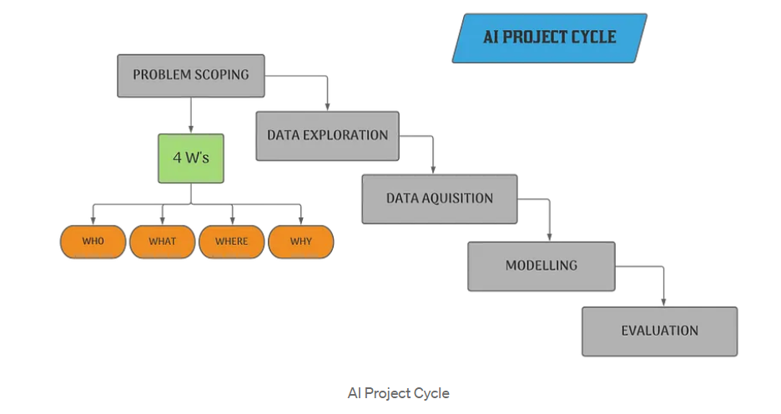

**Problem Scoping:**Whenever we are starting any work, certain problems always associated with the work or process. These problems can be small or big, sometimes we ignore them, sometimes we need urgent solutions. Problem scoping is the process by which we figure out the problem that we need to solve.

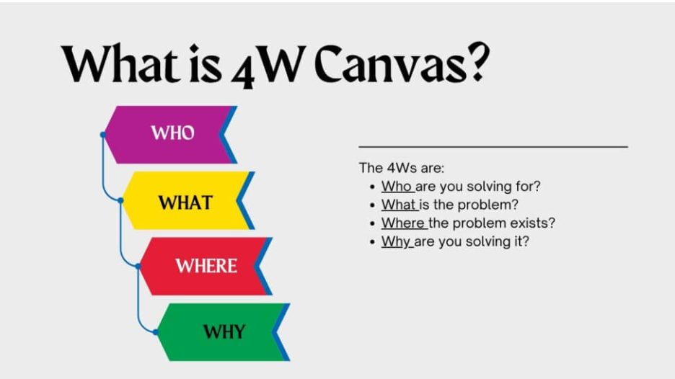

4W Canvas in AI Project Cycle

**The 4Ws Canvas:**The 4Ws Canvas is a helpful tool in Problem Scoping. Basically, questions which help us understand the problems in a better, more structured way.

* **Who?:** Refers that who is facing a problem, who the stakeholders of the problem are and who are affected because of the problem.
* **What?:**Refers to what the problem is and what you know about the problem. What is the nature of the problem? Can it be explained simply? How do you know it’s a problem? What is the evidence to support that the problem exists? What solutions are possible in this situation? etc. At this stage, you need to determine the exact nature of the problem.
* **Where?:**It is related to the context or situation or location of the problem, focus on the context/situation/location of the problem.
* **Why?:**Refers to the reason we need to solve the problem, the benefits which the stakeholders would get from the solution and how would it benefit them as well as the society, what are the benefits to the stakeholders after solving the problem.

**Data Acquisition:**

As you start collecting the photographs, you actually acquire data in a visual form. This data now becomes the base of your security system. Note that the data needs to be accurate and reliable as it ensures the efficiency of your system. This is known as Data Acquisition.

**Data Exploration :**

**•** At this stage, you try to interpret some useful information out of the data you have acquired.

• For this, you explore the data and try to put it uniformly for a better understanding. This is known as Data Exploration.

**Modelling :**

• To implement your idea, you now look at different AI-enabled algorithms which work on Computer Vision (since you are working on visual data).

• You go through several models and select the ones which match your requirements.

• After choosing the model, you implement it. This is known as the Modelling stage.

**Evaluation:**

• As you move towards deploying your model in the real-world, you test it in as many ways as possible. The stage of testing the models is known as Evaluation.

• In this stage, we evaluate each and every model tried and choose the model which gives the most efficient and reliable results.

